Experiment with lift by _______________________
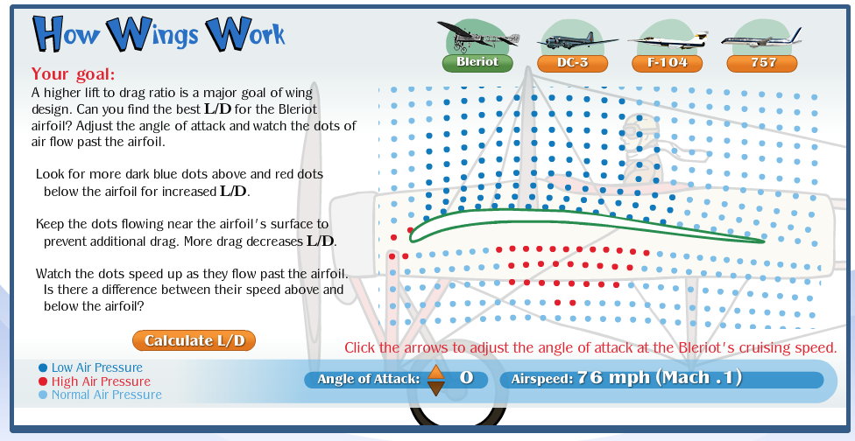
Go to this site. http://howthingsfly.si.edu/activities/how-wings-work . Don’t use Chrome, it needs to use Flash to work.
Choose 2 different wings and describe what angle of attack made the best lift to drag ratio.

Which wing: | Which wing:
What angle of attack was best? | What angle of attack was best?

Describe what the airflow looks like when a plane is flying efficiently.

Experiment with lift by _______________________
Go to this site. http://howthingsfly.si.edu/activities/how-wings-work . Don’t use Chrome, it needs to use Flash to work.
Choose 2 different wings and describe what angle of attack made the best lift to drag ratio.

Which wing: | Which wing:
What angle of attack was best? | What angle of attack was best?

Describe what the airflow looks like when a plane is flying efficiently.

Go to this site http://howthingsfly.si.edu/activities/forces-flight
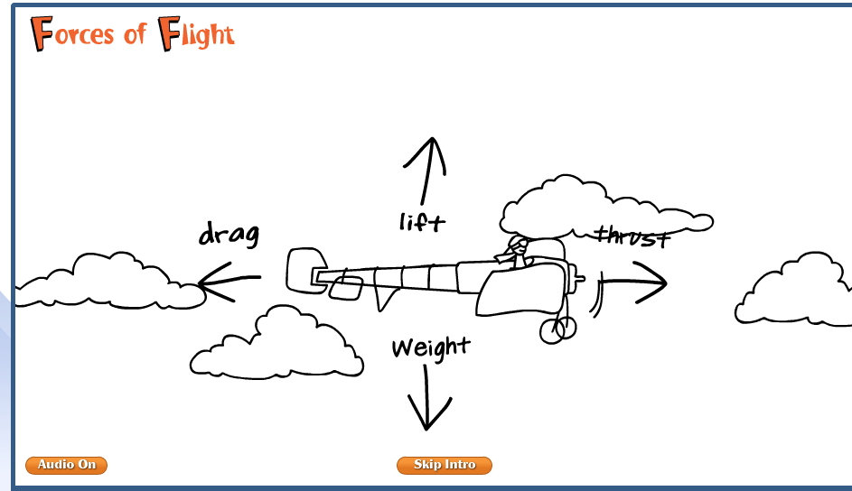
Design the highest flying plane you can.
What lift did you use?
What drag did you use?
What thrust did you use?
What weight did you use?
How high did the plane fly?

Go to this site http://howthingsfly.si.edu/activities/forces-flight
Design the highest flying plane you can.
What lift did you use?
What drag did you use?
What thrust did you use?
What weight did you use?
How high did the plane fly?

